PowerApps Trial without Work email

1. Open <https://dynamics.microsoft.com/en-us/dynamics-365-free-trial/>
2. Click on Try for Free
3. Enter Temporary email generated from [Temp Mail – The Best Temp Email Inbox](https://tempmail.email/) in the Email

id field.

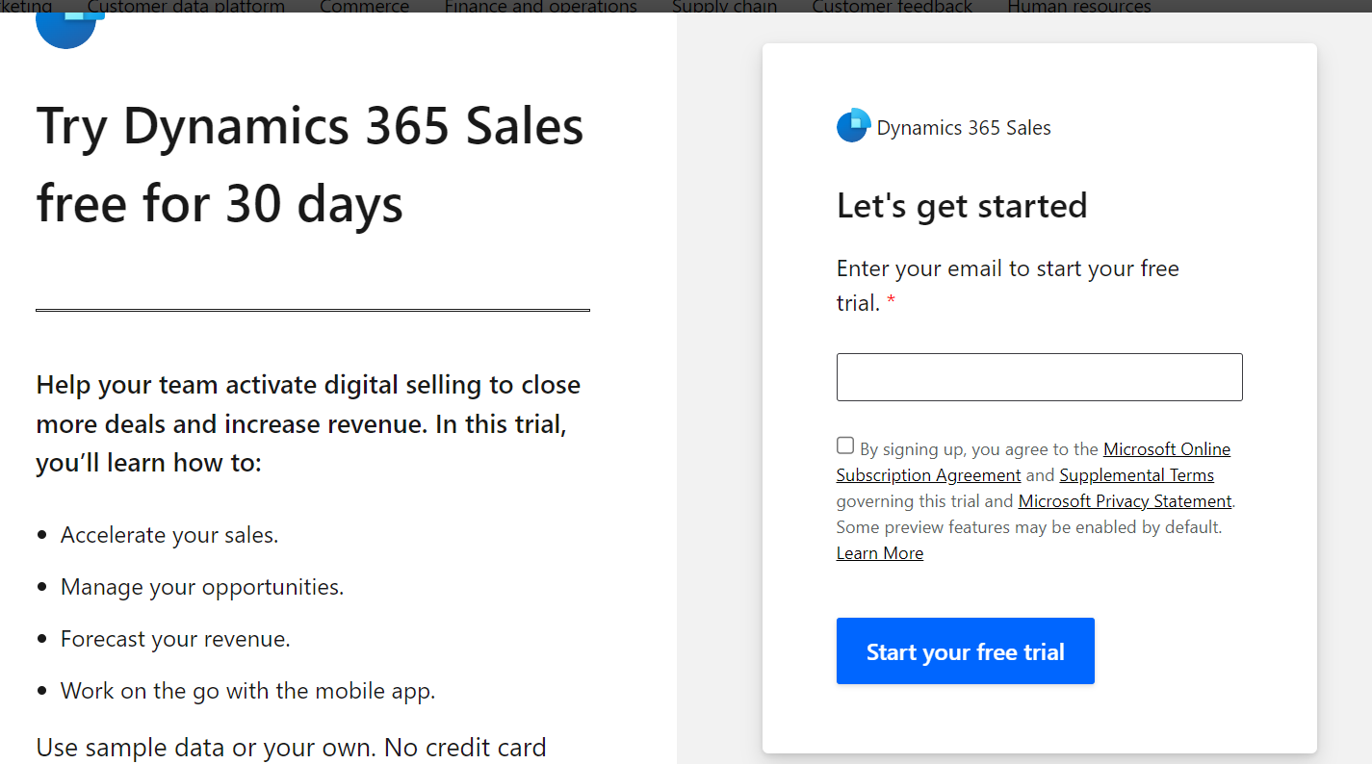

1. After Entering Temp email you will get an error that email cannot be connected with Microsoft services. Click on set up to set new account.

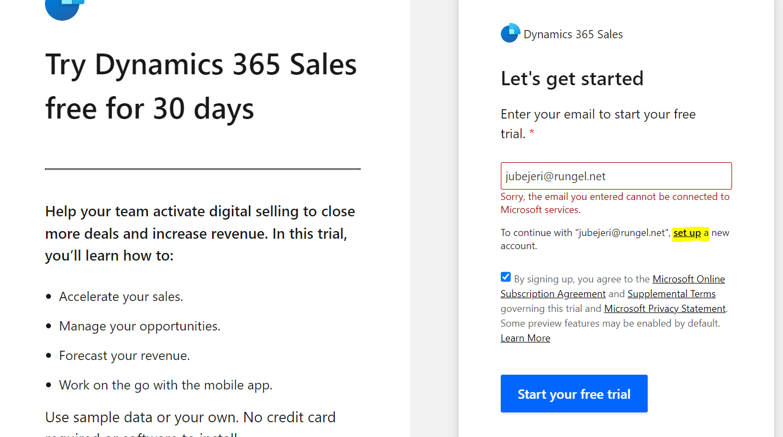

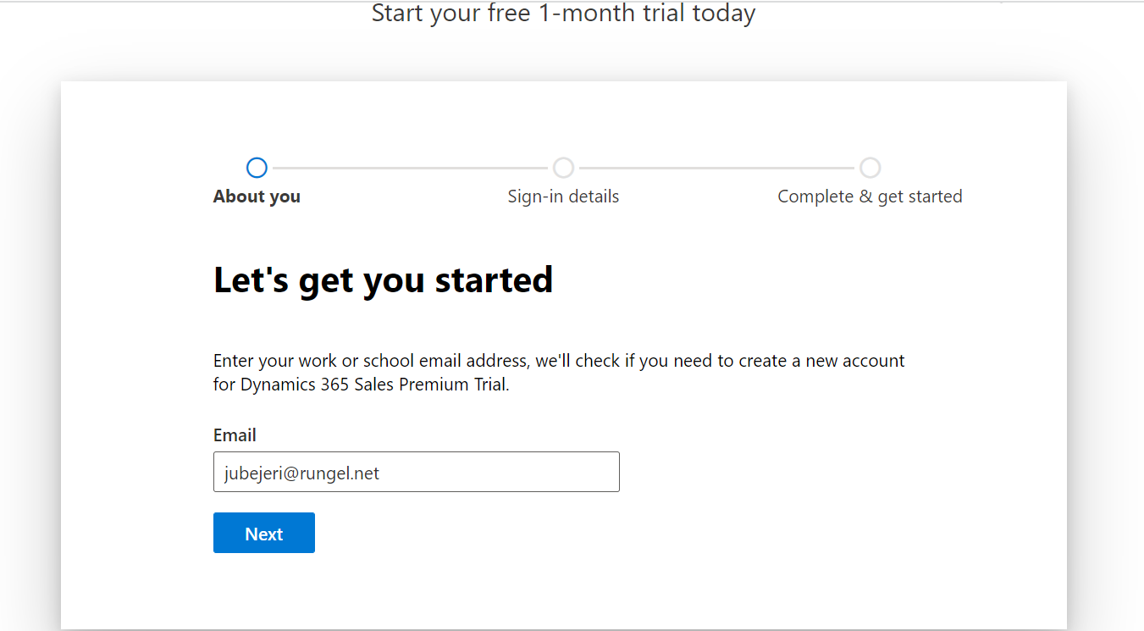

1. Click Next.

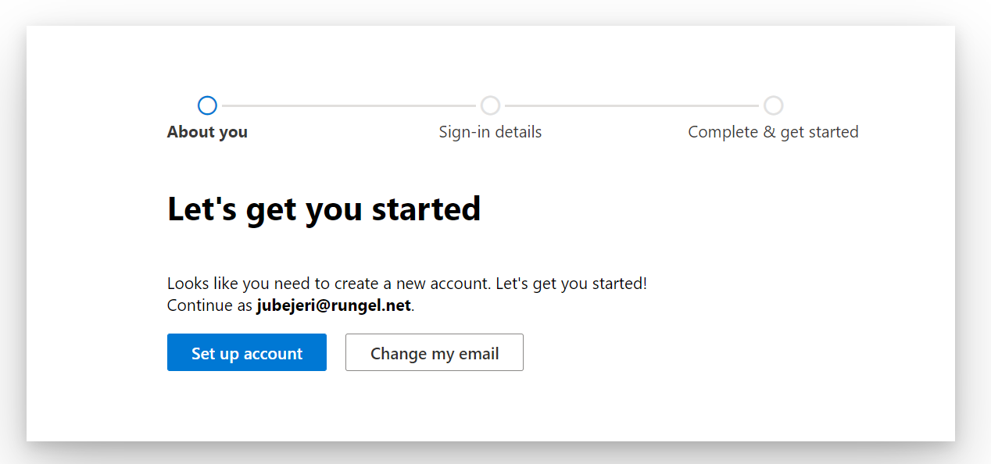

1. Click Set up account
2. 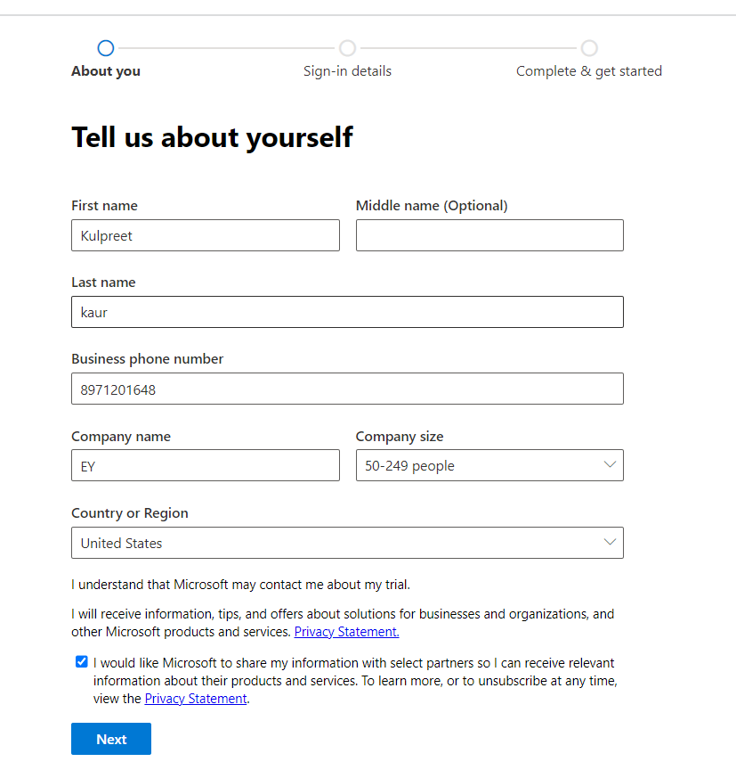
3. Fill in your details and click Next. Make sure you give correct mobile number to receive otp.
4. Once your verify your account you will be redirected to below screen
5. 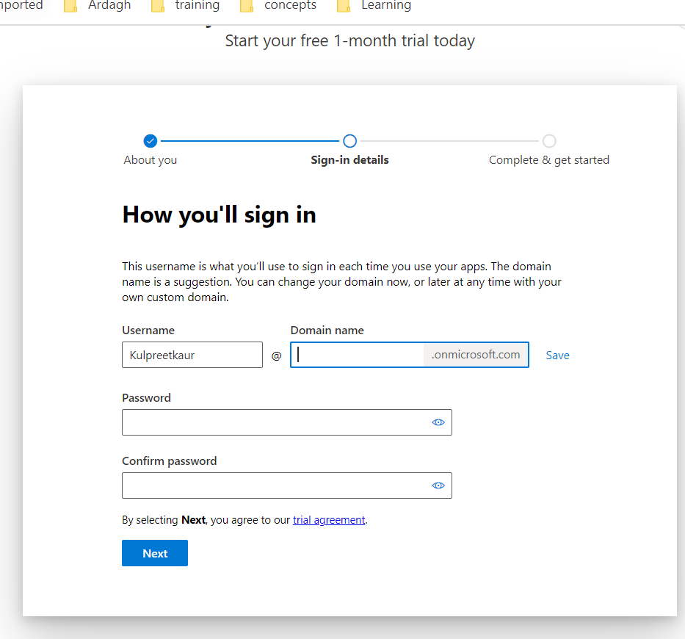
6. Enter the Domain which you can remember or is relevant and enter the password click next.
7. You will get your username after this step.
8. 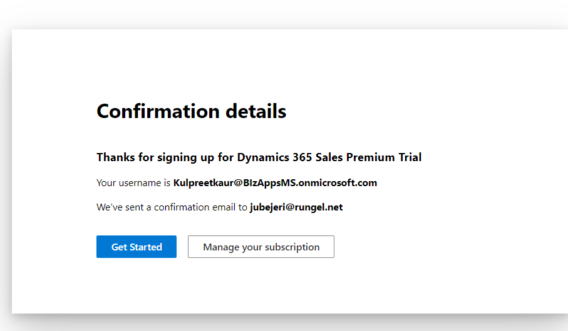
9. Save that username and password and you can use same to login in <https://make.powerapps.com>